****

**Making maps with Google Fusion Tables**

**January 2016**

**Ronald J. Hansen**

There are many tools for visualizing data, and many have value depending on your individual needs. Ease of use, cost, aesthetics and the ability to post online or share with others are some of the more important considerations. Here is a guide to getting started on Google Fusion Tables.

FT is free (!) and widely available through the Google platform. FT takes your data, or someone else’s, and quickly displays it and shares it to your selected audience or makes it publicly available to everyone if you prefer.

Maps and graphics have two basic uses in journalism: They can inform our reporting and they can inform our audience. There are several types of visualizations FT can do. I want to focus on two: location maps and intensity maps.

Location maps can help us understand location, distance from key points and even sequential movement. Intensity maps can help us understand relative value of one place to another.

I’m including my Excel cheat sheet for you. (It is the bedrock on which much of data journalism and the data world rests. If you learn only one thing, make it Excel.)

I recommend you clean your FT data in Excel (or Google Sheets or some other program) before you try to work with it in Fusion Tables. You can edit in FT, though it is relatively clunky compared to what you can do in a spreadsheet.

Google created Fusion Tables in 2009, but still considers it an “experimental app.” Over the years it’s gotten a lot easier, with added functionality. Still, it’s a work in progress, which means that what’s true or limiting about it today may well change tomorrow. As with most technology questions, try finding help on Google, YouTube and the NICAR listserv.

Let’s make our first map.

For this, we’ll start with something easy: a list of state capitals with some other basic information. You could probably find this from many sources. I chose Wikipedia because it was already put in spreadsheet form online. This usually makes it easy to import into Excel. Here’s the link and what the relevant table looks like:

<https://en.wikipedia.org/wiki/List_of_capitals_in_the_United_States>

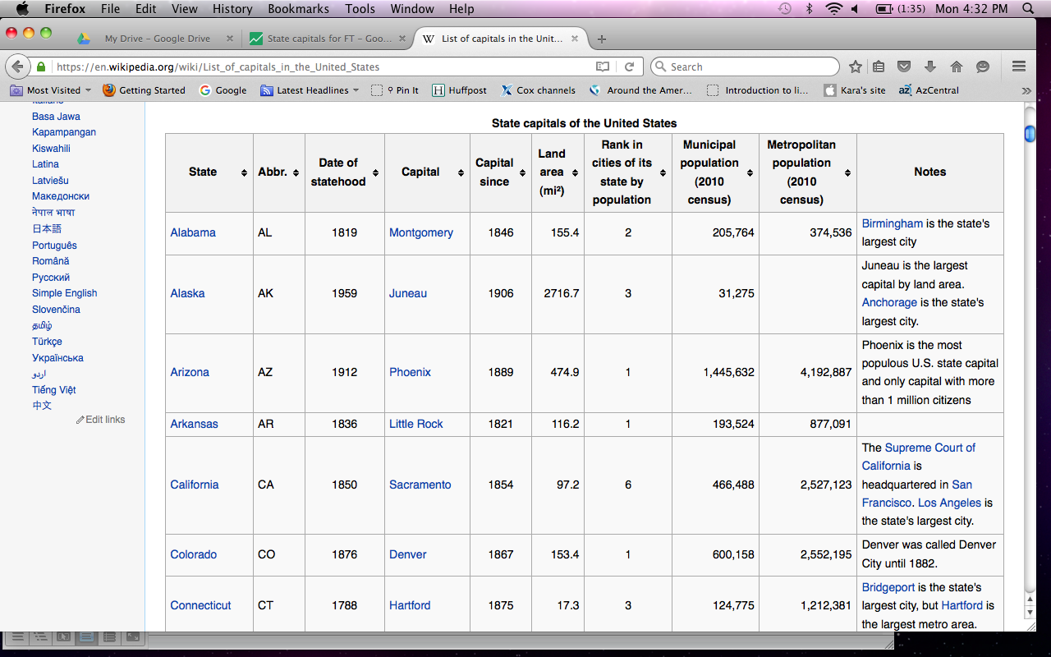

I copied and pasted this into Excel. Next I copied it into another worksheet (giving myself an untouched original if I needed to go back to it for some reason). In the second worksheet I made a series of modest changes.

**TIP: Fusion Tables can be particular, so try to conceptualize your finished map before you start working in FT. The goal is to identify what you will need from the start. The most important thing for a map is to ensure FT will be able to recognize your intended geography.**

For this map, the key is to have Fusion Tables correctly locate our state capitals for us. The data identifies the state and the capital city in it, but it doesn’t combine the two. Depending on the place you’re trying to locate on a map, the name alone might work. Don’t be surprised, however, that many times it will not work.

To get around this, let’s create a new field in Excel that combines the city and state. This is easy. My preferred way is to write a simple formula that joins two cells using an ampersand. It’s structured like this:

=*(cell address 1)*&“, ”&*(cell address 2)*

For my data, the city name is located in the D column and the state name is in column A. It begins in row 2. So the actual formula looks like this:

=D2& “, ”&A2

The quote marks give Excel instructions to put what appears within the marks into the new cell. In this case, it grabs the text Montgomery from cell D2 and inserts a comma and a space immediately after this followed by Alabama from cell A2.

It produces: Montgomery, Alabama

Google can understand this, so copy the formula down to all the cells in the spreadsheet. Save the spreadsheet and go to your Google Drive account.

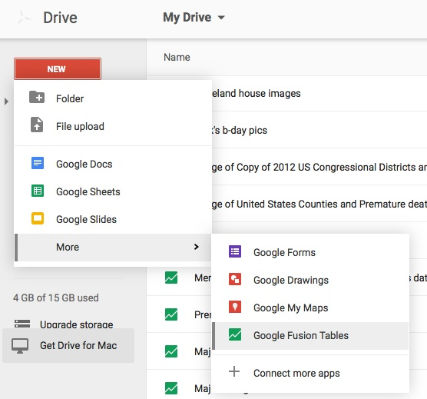

Let’s import this data into Fusion Tables. From the Google Drive page, click on the red New button.

You won’t see Fusion Tables, so select More, then look down to find Google Fusion Tables and click on that.

Now you’ve got to tell Google what data you want to use. In this case, I hit Browse and selected my Excel file called State capitals for FT.

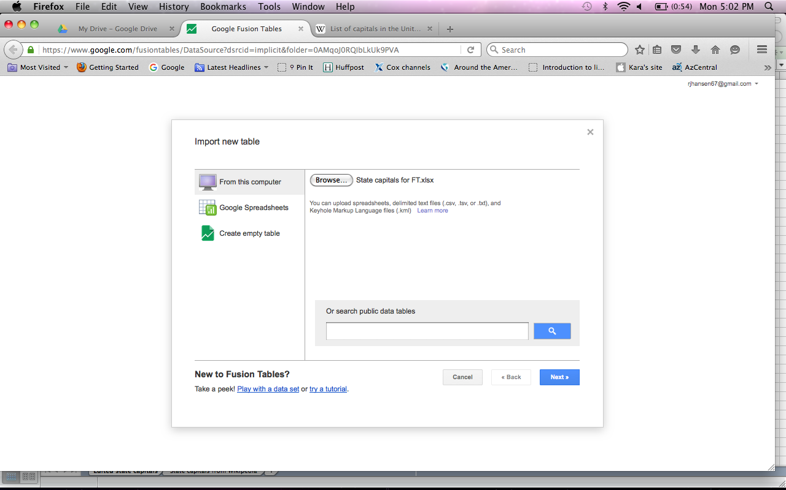Once you see your file in the right place, select Next and Google should start importing your data.

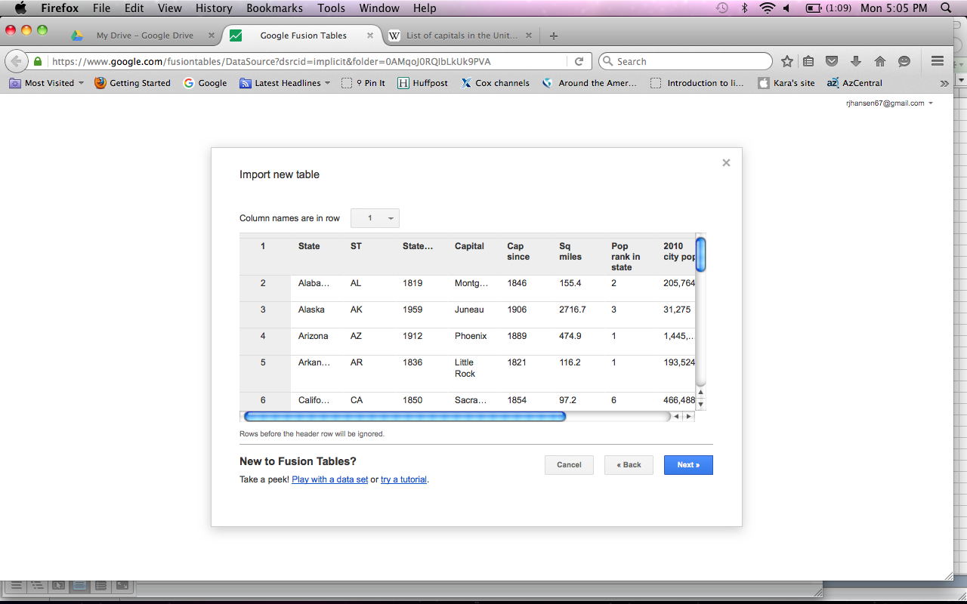It should open a window showing you a preview of your data with its best guess as to which row contains your column headers.

I recommend keeping your data for FT beginning on row 1 to avoid any problems.

If the preview looks right, click Next.

This brings up a screen to name your file and include any sourcing notes and relevant page links. This is a chance for you to make relatively detailed notes on your data source or shortcuts to get back to that source if you want. If your data is primarily for your use, you may want to skip most of this and hit Finish.

Google pulls in your data and (eventually) displays it in a spreadsheet format that should look recognizable to you.

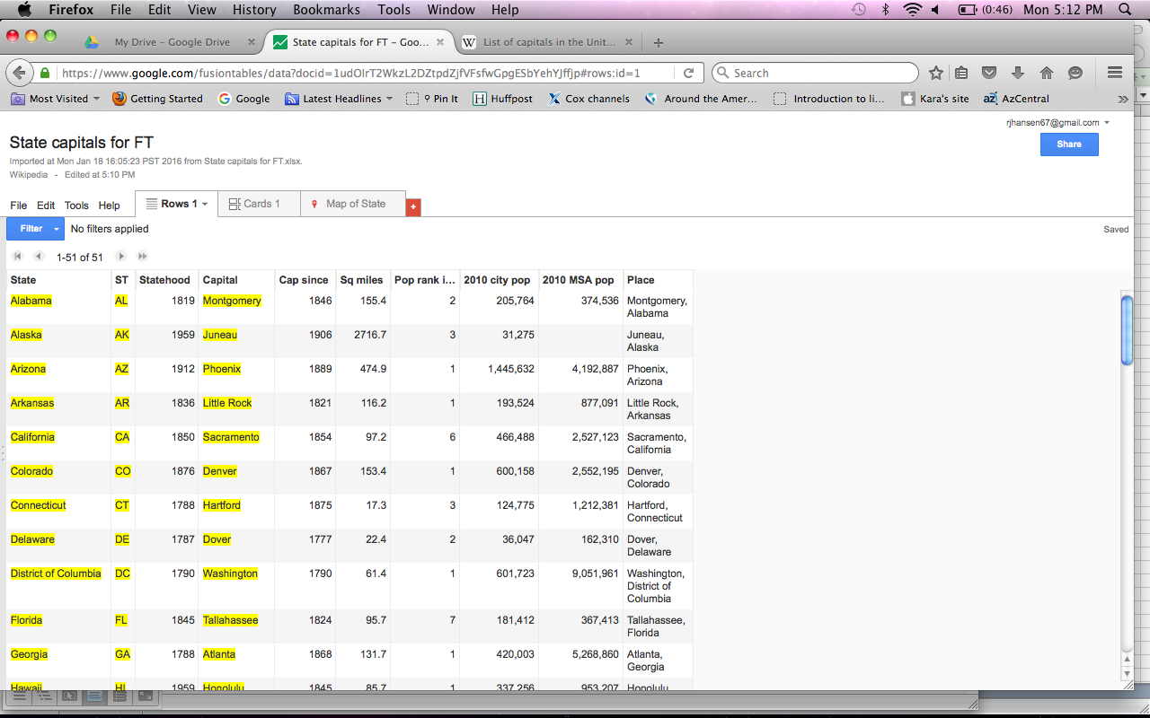

Now you’re working in Fusion Tables. The rows shown are part of a tab identified as Rows 1.

Further to the right, you’ll see a tab for Map of State. These are the two areas you’ll usually work in with FT.

The Cards 1 tab is another way of visualizing the information. It looks like an index card. I don’t typically find this helpful, and usually ignore it.

The information in yellow is a sign that FT thinks this information can be geocoded.

Fusion Tables has gotten pretty good at recognizing actual geographic areas and conventional addresses. If we wanted to simply display a point on the map for, say, Alabama, FT would do it pretty accurately.

We want to see FT display our state capital locations on the map. Click over to the map tab and let’s see what we get.

So Google tries to geocode the information labeled State. If you let it finish, it does a good job of identifying each state, but that’s not helpful for us. On the left rail, you’ll see an option to change the map configuration. Change the location from State to Capital. It will open another box as it attempts to geocode using the data in the Capital column.

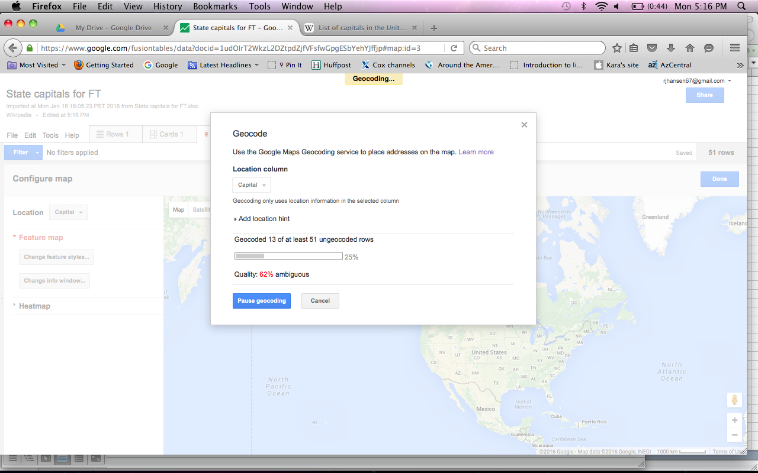

You can see the progress and the level of ambiguities Google is running into. You can pause the geocoding and select another possible source for it to use. Let’s finish geocoding the Capital column. When it’s done, the resulting map is pretty good, but it’s not perfect. You’ll notice that using Augusta only, Google put a marker on the map for Augusta, Ga., not Augusta, Me., even though the other information in the row says Maine.

**TIP: Google doesn’t do a great job of interpreting context, so be precise to avoid ambiguity.**

The bottom line is we need to geocode the column we created that combines the city and state. Click back to the Rows 1 tab. Find your column for Place and click on the inverted triangle (pyramid?) to show options. The first option is Change. Choose that.

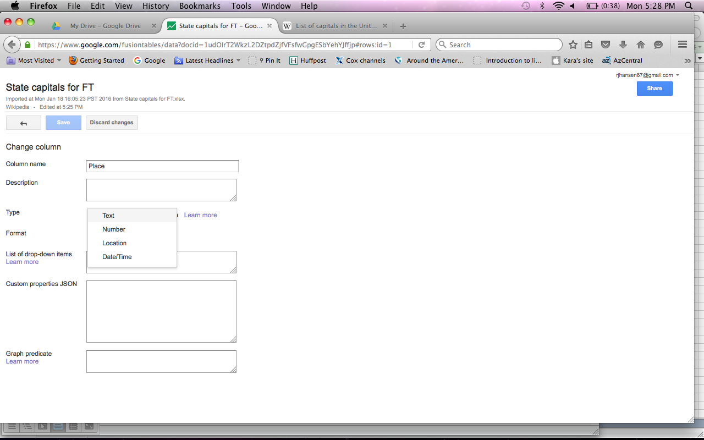You’ll see a box that looks like this and has options when you click on Type.

As you can see, one of them is Location. This gives Google instructions to treat all the data in this column as though it’s something it could geocode.

Choose Location and Save it with the blue button at the top. Google quickly reassesses your data and should display all the rows again. This time, the Place column is also in yellow.

Go back to the Map of State tab. Under Configure map, you’ll have an option now for Place. Choose that.

Google begins geocoding again. It should not have any ambiguities as it goes over locations like Phoenix, Arizona. When it’s done, you should see a map that has red dots where you would expect to see them for each capital. Look, for example, at Augusta in Maine and Georgia.

At this point, our map is really done.

So what can we do with this?

For one, we can share it. Click the blue Share button in the top right corner.

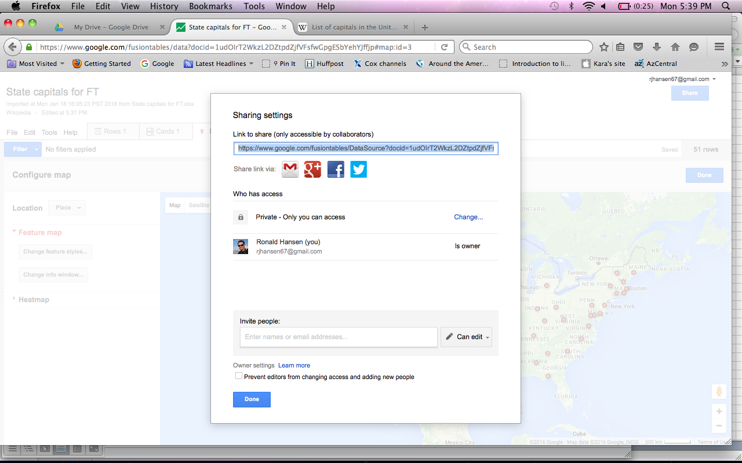This opens a box that gives you several options. There’s a link you can copy and send to someone (or keep for your own records).

You can change the settings so that only you can view this map. You could also make it public to anyone with a link or public to anyone in the world.

You also have the option to invite others to review the map and data. As part of that, you can choose whether to allow them to edit the information or lock it down for review only.

When you’ve made your choices, click Done.

Here are a few thoughts about how this map could be used.

First, a map has the ability to make spatial relationships more clear. Quick, without looking at your map, do you know which two capitals are the closest together? Intuitively, you might think it’s someplace in the east and could guess. Looking at the map, however, helps you focus more quickly on what the answer might be. (It’s 50 miles from Boston to Providence. Or 31 miles from Annapolis to Washington, if you count the nation’s capital.)

One of the features FT has is a filter that sorts the data like a filter in Excel, but keeps it on display in your map. Let’s find out how many state capitals are part of large metro areas, which we’ll define as having 1 million or more residents.

Click the blue button on the left side of the screen that says Filter and select the category labeled 2010 MSA pop. You’ll see places to put in numeric ranges for FT to look through. It also tells you the range it sees in the data. In this case, it ranges from nearly 71,000 to more than 9 million. Put 1000000 in the left box and click Find. You’ll notice it treated this as a request for anything with 1,000,000 or more. We could have identified an upper bound, but didn’t need to.

On the far right, FT tells you there are 17 rows that meet this criteria. The map should maintain red dots that identify where these markets are located.

You can use more than one filter at a time. If you click on Filter again, you can pick additional criteria and again set the parameters. Picking the Cap since data gives you the chance to identify capitals within a time range. I put 1800 in the right box and FT treated that as an instruction to find capitals in MSAs with 1 million or more that have been capitals before 1800. There are three: Boston, Richmond and Washington, D.C.

You can clear the filters by clicking the X in the top right corner of where the filter parameters are located. Your map is updated to reflect these changes.

This is a simple map, so it has limited value. Let’s move to something else.

Now let’s make a map of Congress.

First, you’ll need the data, something I’ve already pulled for you.

Remember, you want to think of the finished product from the outset. The key for this map is to be able to display congressional district boundaries and the members that correspond to each of those in a distinctive way.

There are different ways of identifying congressional districts. I selected this format:

*State abbreviation*-*number or at large*

So for Alaska’s at-large seat, it looks like this:

AK-AL (not AK-1)

Arizona’s first district is:

AZ-1 (not AZ-01, though we could have used this)

California’s 13th is like this:

CA-13

Our data has several important fields. It includes the member’s name, their party affiliation, their state, their district ID and telephone numbers in Washington and in their district.

I included one more bit of information for mapping clarity. I added a column in Excel that assigns a color to a district based on the party affiliation. In other words, seats held by Republicans are noted as red and seats with Democrats are blue.

Follow the importing instructions again to load this data into your Google Drive.

This should create a file that has yellow geocoding possible for the states, but not for the congressional districts. This isn’t surprising and turns us to the namesake reason for Fusion Tables.

We want to merge (fuse!) this data with another dataset that already exists with the congressional boundaries and their corresponding shape files.

The shape files are typically stored in what is known as Keyhole Markup Language, or KML. This involves lots of coding instructions that don’t matter to us, but gives Google instructions on how to draw polygons precisely.

Fusion Tables allows you to search publicly available resources for KML and other data you can pull into your map.

If you know you need to find shape files, it’s a good idea to find your KML partner before you load your data into Fusion Tables.

In this case, I know I need the boundaries for the 114th Congress. (These boundaries change every 10 years beginning in years ending with the number 2. Ex: 1992, 2002, etc.)

Here’s one place to look in Google for publicly available maps:

<https://research.google.com/tables>

And here’s what it looks like:

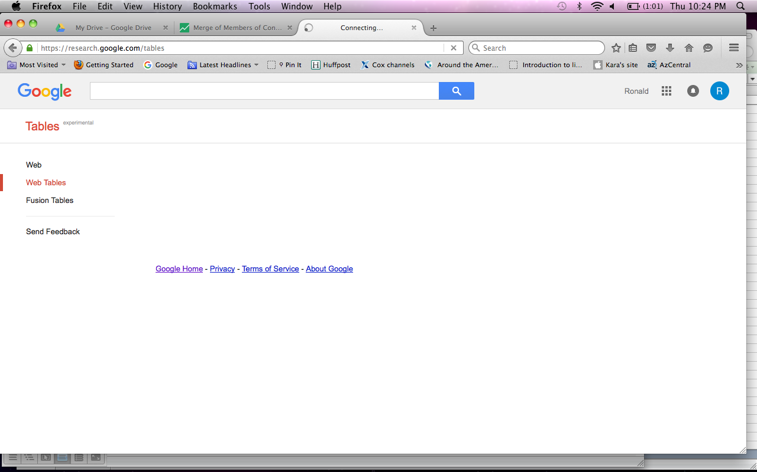

Click on the option labeled Fusion Tables and type in your search terms.

I used 2012 us congressional districts.

The file that seemed cleanest and most on point was one called Copy of 2012 US Congressional Districts:

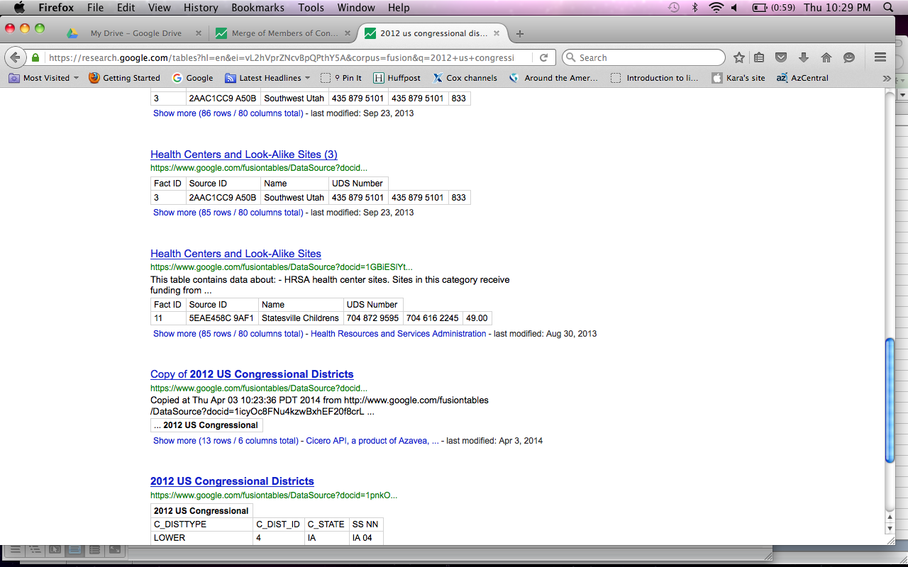As you can see, there are many options and I don’t swear that this is the best one to use. It’s the one I picked that looked reasonably likely to give me what I wanted. Depending on what you’re looking for, this search can be one of the hardest parts of making a map.

We’ve found the one we want so we need to tell Google to merge this one with the file we created.

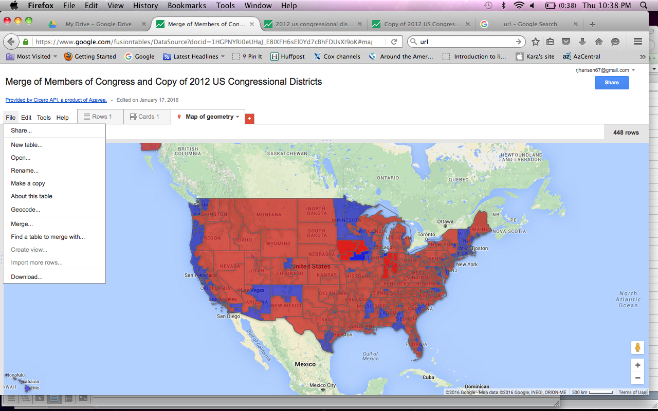Click on the link for the 2012 boundaries. Each of these maps produces a unique URL. You can tell Google to merge from your map or the public map. I prefer working with mine, but it truly doesn’t matter.

Copy the URL for the public map and in your map, click File and select Merge. We could browse our options by selecting Find a table to merge with, but I find this to be an unwieldy way of doing it.

After you’ve clicked Merge, Google opens a window with several options for you. In this case, let’s paste the URL we copied into the bottom line and hit Next.

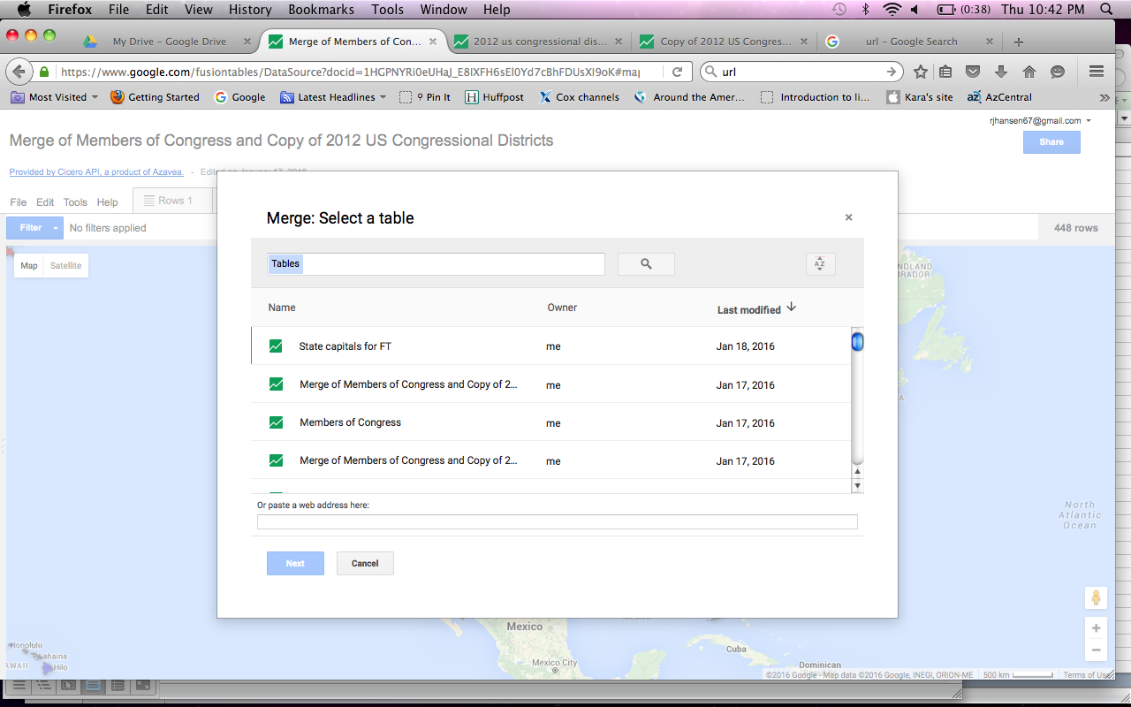

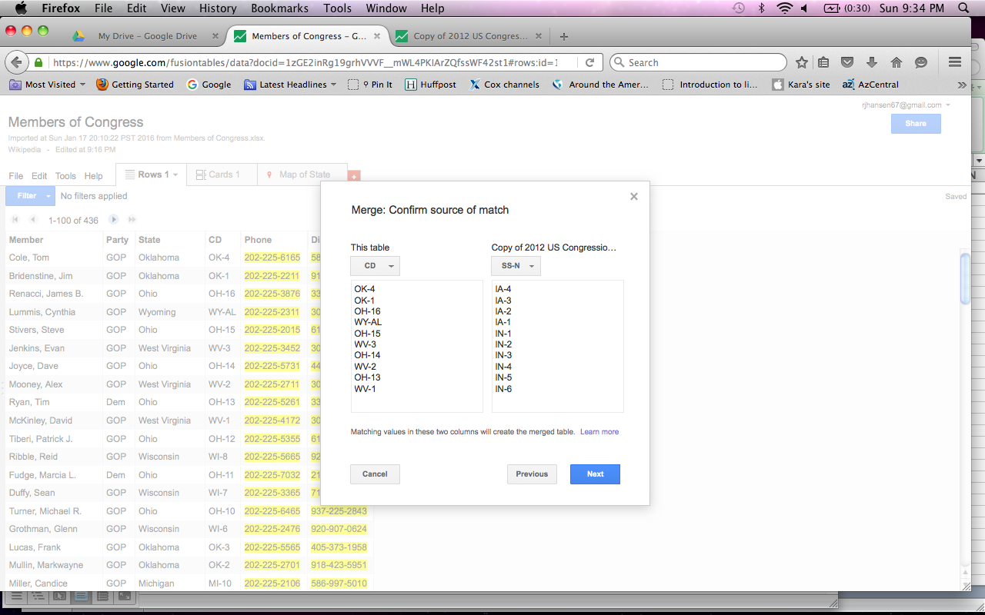The way these various files are joined is by identifying something they have exactly the same. In this case, it’s the district ID. I structured our data caption to match the style used in this map.

Give FT the column to join these tables with. It’s the column labeled CD in our data and the one labeled SS-N in theirs. Once you’ve identified these, hit Next.

Google will ask you to select the columns you want to pull together. Unless there’s a good reason to exclude data, I usually include all of the columns. Choose Merge. A box pops up telling you there’s a merged table available. Choose View table.

Now you should see the merged spreadsheet information. If you click on the Map tab, you should see something like this:

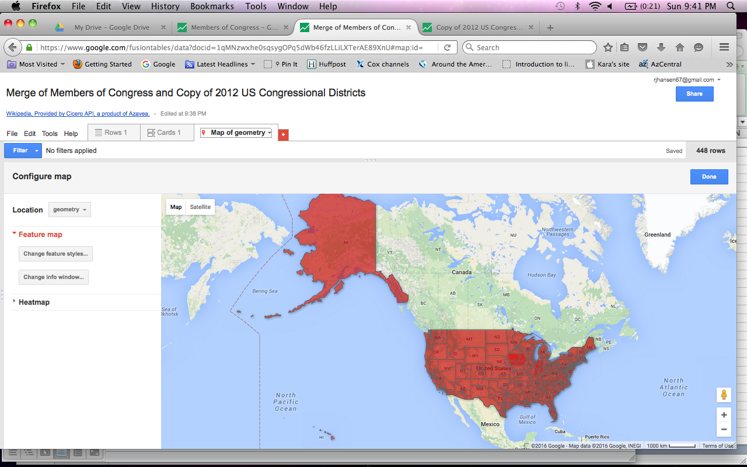

If you zoom in on the map a bit, you’ll notice that it does appear to have congressional boundaries on it, though we’ve got some work to do to make this more helpful.

Click on a place on the U.S. map and it should pop up with information from the spreadsheet to tell you who represents that part of the country. It’s obvious we need to edit this and give it some color to distinguish the districts, politically speaking.

Let’s change the info box first.

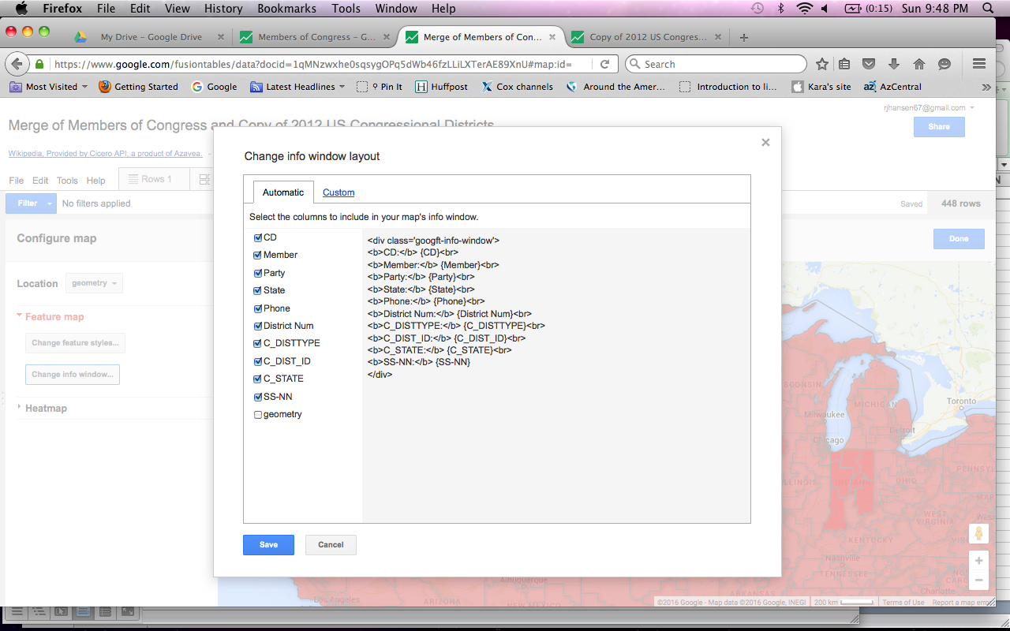

There’s a box in the left rail called Change info window. Click that and let’s make a few changes.

In the dialog box you’ll recognize the information from the columns. Most are checked, which means they are displayed in the info box. We don’t really need the ones from the other data set, so let’s uncheck those boxes. Hit Save.

To the right is the HTML code that corresponds to each of the checked items. As you add or remove items, you should see that change, too.

That gives us an info box that seems more helpful. We’ve got the district identified and the person who represents it, their party affiliation and their phone numbers in Washington and in their district.

Let’s turn to the map colors.

Above the button for changing the info box is a button labeled Change feature styles. Choose that.

This brings us to what may be the trickiest part of FT. Points are specific places. They can be as big as a country or as small as an address (or even a lat-long point, too). We used points to indicate where our state capitals are in the earlier map.

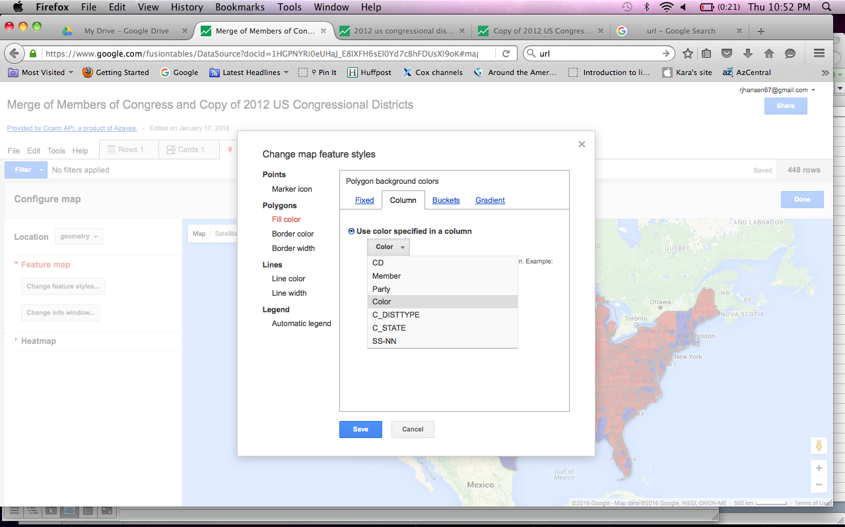

This map needs to use polygons to display the unique shapes of each congressional district. That’s what we want to change here.

Let’s use the usual political coloring, assigning each district held by a Democrat the color blue and each Republican-held seat red. Click on Fill color.

Here there are several choices (Fixed, Column, Buckets and Gradient).

Fixed allows us to map something based on a color choice. This is handy when your map has a relatively limited coverage area that you’re trying to display. If we were mapping, say, the area affected by a wildfire, making it all one color would be a sensible way to display it.

The Column option allows us to designate a column that provides guidance on how to color code maps that need multiple colors. That’s a good fit for this one because our map actually covers the entire U.S. Remember, our original data uses red and blue based on party affiliation. Choose Column and select the Color option.

Buckets allow us to divide the map into colors based on grouping a piece of our data. For example, you could have a map of cities within a state and group those cities based on the number of hospitals they have. FT lets you manually set the number of buckets and the parameters for each. It also makes suggestions based on the actual numerical range of the data.

Gradient offers similar control but offers more subtle indications of change.

Back to our congressional map. After making the Column>>Color change, you can close the left rail by choosing the blue Done button. It should display your map with the appropriate colors. It should look like this:

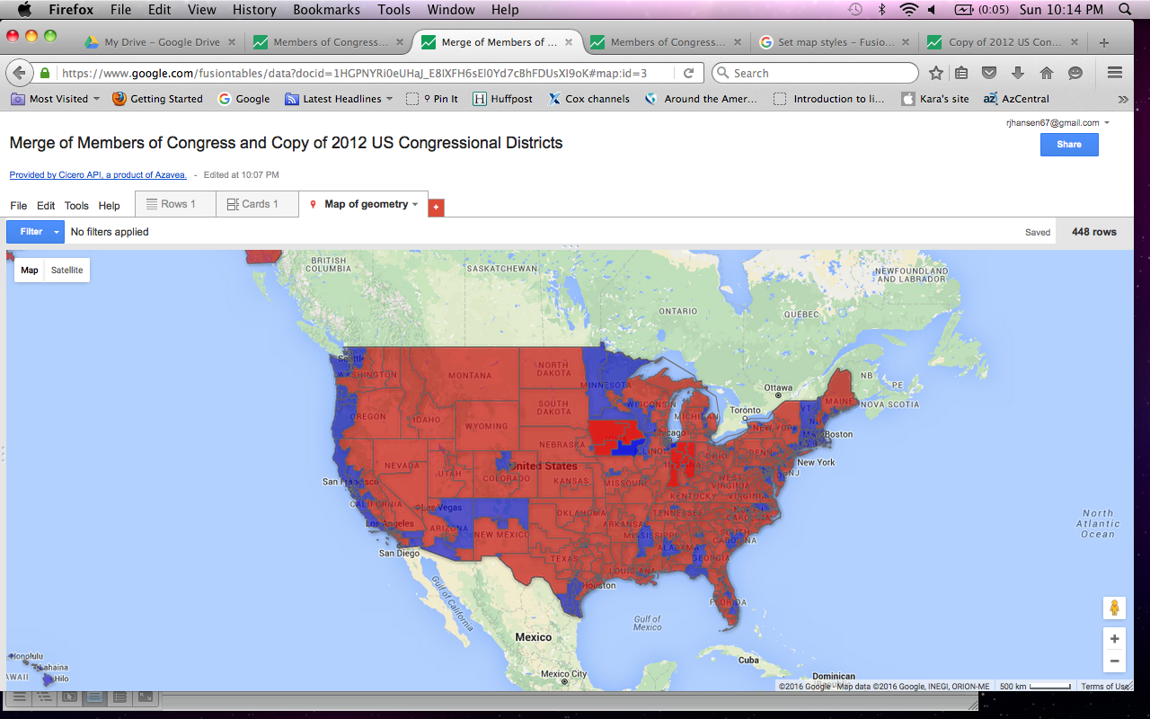

So what can this map tell us?

Probably most clearly is how much real estate is Republican red. This graphically displays what we probably know, but don’t always visualize. If you filter for the Democrats, you can see pretty clearly how they dominate the northeast and West Coast.

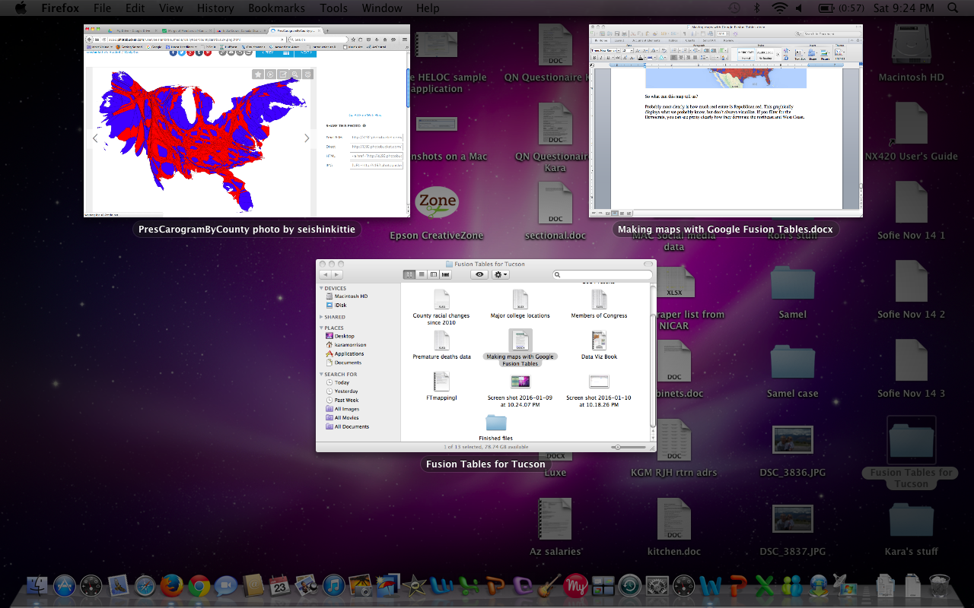At left is a cartogram of the 2012 presidential election, by the way. This is a population-based representation of the vote. Essentially it makes clear where the people are. Both maps are important to understanding the nation’s politics.

Back to our map, you could also look for seats that seem especially as partisan outliers. Who and where are those islands of blue in middle America? Similarly, what’s the story of red in New Hampshire?

If we had pulled down more information about, say, seniority, we could filter to see what, if any, geographic subplot might go with that.

Let’s do another map.

OK, to be honest, so far, you could probably make reasonably intelligent guesses about what the state capitals and Congress maps would tell us before you even saw them. (But this is really about learning Fusion Tables more than learning about which big areas are state capitals.)

Now let’s try one that includes more fragmented geography and information you probably don’t know as well.

Next up is a spreadsheet of county-level health-related data from the Robert Woods Johnson Foundation. This is a nonpartisan non-profit that has crunched data from various sources and come up with what purports to be calculations of premature death levels, among other things.

The original spreadsheet has more than 150 columns of data around 35 types of indicators, ranging from incidence of diabetes to length of commutes. In the interest of time, I’ve condensed this to four data points plus geographical information.

This information includes separate columns for the county and state, as well as the FIPS code for each county. (FIPS is the government’s Federal Information Processing Standard. It’s a number-based system to make reference to specific geographies from the state down to the locality within it. Maricopa County in Arizona, for example, is identified as 04013. Arizona is 04 and Maricopa is 013 within it.)

**TIP: Familiarize yourself with the kind of data-tracking systems relevant to what you’re trying to map.**

The FIPS code isn’t a secret or anything you need to memorize, but it is something that can help you separate county-level information. Congressional district IDs are the same concept. They are part of the way Congress sorts its map. The Census Bureau uses FIPS but it also uses things like Census tract numbers as well. These codes can help simplify mapmaking.

I did two preliminary data-cleaning things to this data. First, I created a county-state column to combine that information in one spot. (I didn’t do anything to distinguish Alaska’s boroughs or Louisiana’s parishes, so apologies to them in advance.) I also created a FIPS code that was a number rather than text. That means dropping a leading zero in some cases.

Upload your data to Google and get it into Fusion Tables following the usual steps. In a case like this, I would probably include a link to the original data for readers and myself.

FT thinks it can geocode our county-state column, but it’s very time-consuming and still doesn’t produce the polygons we want. This means we want to find a file with KML for the counties.

Look for such a file here:

<https://research.google.com/tables>

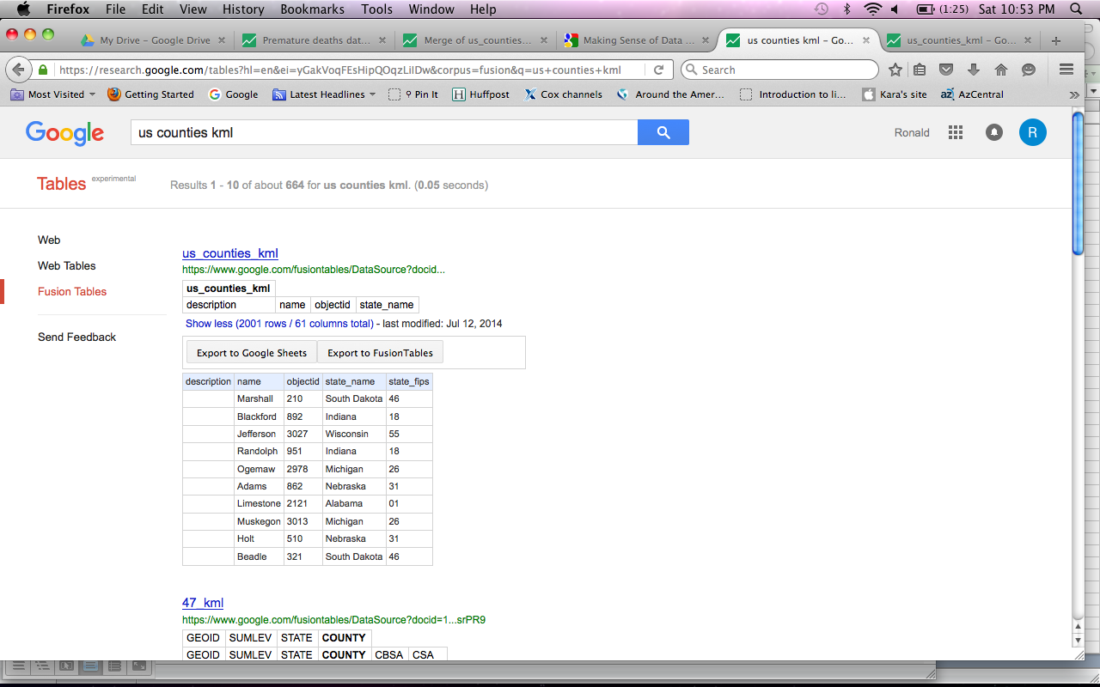I searched using the terms

us counties kml

and got exactly what I wanted.

If you click on that file and look at the map it produces, you should see something that looks like the county boundaries nationwide.

You’ll also notice it uses the FIPS code. This seems a decent map to merge with, so grab the URL and merge with your data.

Use the FIPS code that Google identifies in both of these files and finish merging them.

As a bonus, we’ve now got a map that ties the health data we uploaded with the boundaries of another file that helpfully includes U.S. Census Bureau data as well.

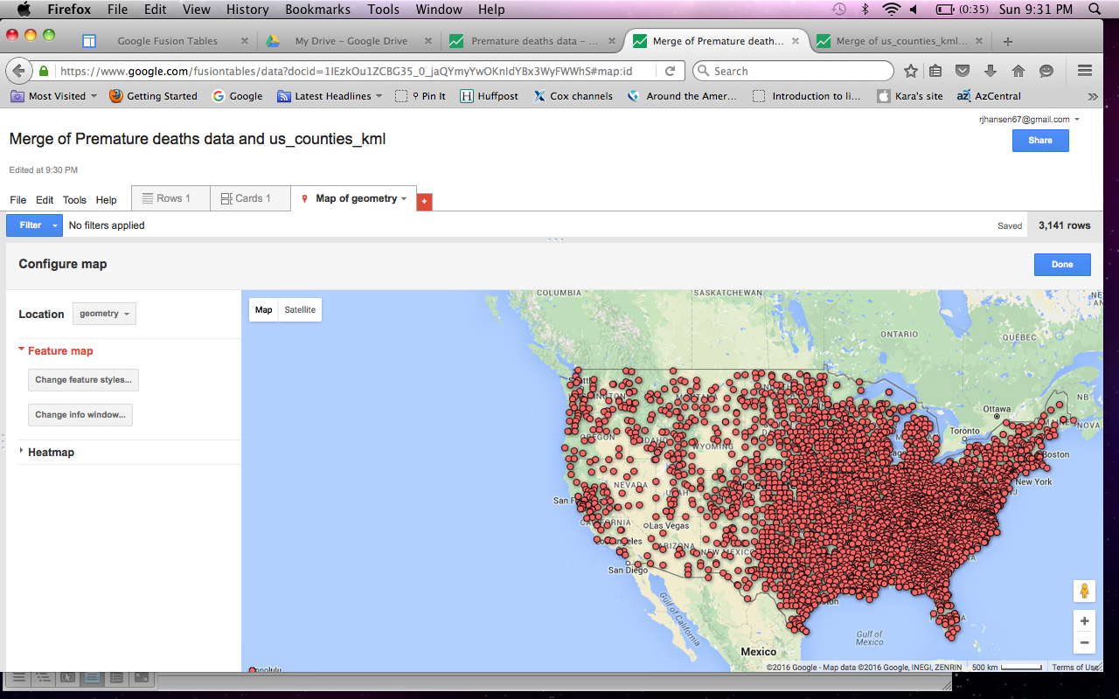If you click over to the map, you’ll probably see a series of red flags. Zoom in closer and you should see what you want.

As you can see, the map now has red polygons for each county in the country.

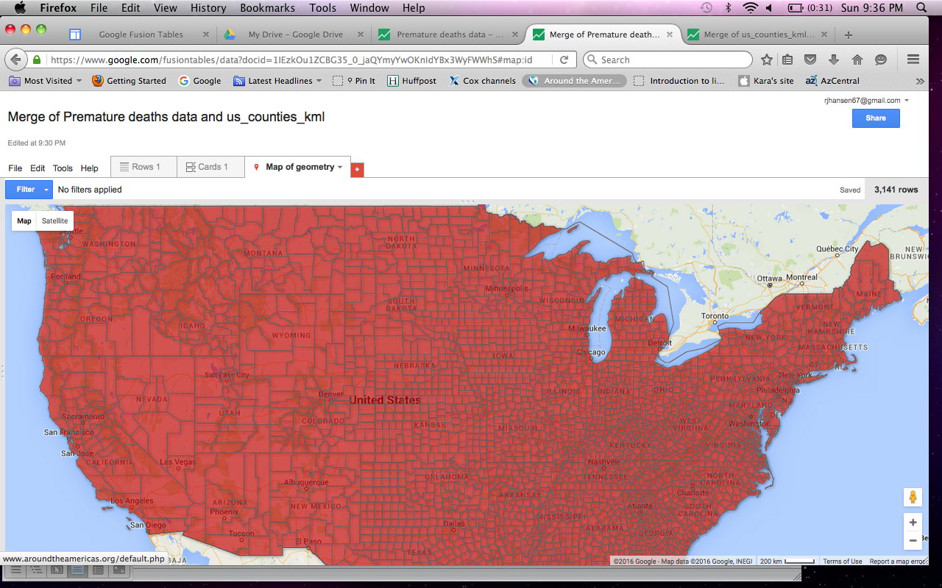We need to change the colors to something informative. This means we need to assign colors based on a data point.

Click on Tools and select Change map or click on Change feature styles in the left rail if you’ve got that open.

Under Polygons, choose Fill color. Across the top right, you have your options for Fixed, Column, Buckets and Gradient. Choose Buckets select the number of color buckets you want. For this kind of a map, I think you need at least three colors and probably no more than five, but this is strictly a matter of personal preference.

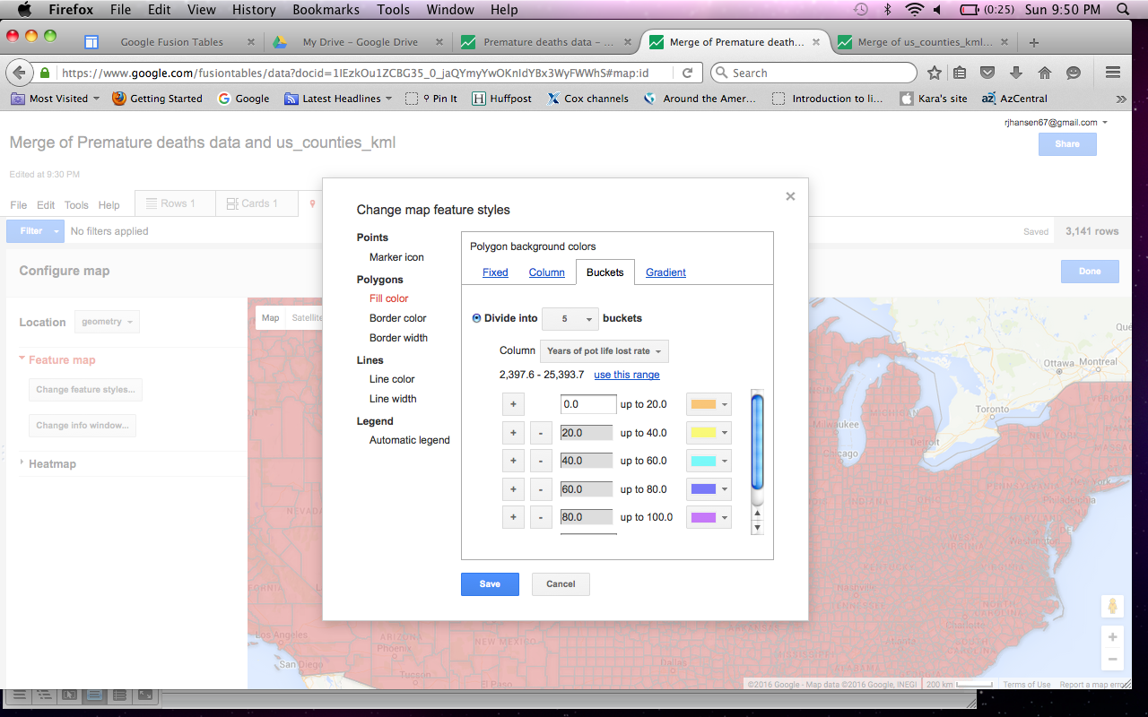After you’ve picked the number of buckets (I chose five), you have an option to tell FT what data point you’re separating the data on. Let’s start with the one that calculates the years of potential life lost.

Notice that FT has a readymade scale with some selected colors in the box for you. If you study the numbers, though, this scale is not especially applicable.

But underneath the column selection tool is a range indicator that shows the minimum and maximum values in that data. Click use this range. FT automatically spreads the data equally based on the number of buckets you’ve selected and the data range.

If you want to change the colors, you can do that with the pull-down menus next to the colors displayed. I kept the colors Google picked. Click Save and your map should be recalculated to reflect the variation in that data category. Click Done in the top right corner to get rid of the options on the left rail.

Modify the info box to show the information you really want for every county. Also, the color scheme could use a legend. Click on the Change feature styles button again. At the bottom is an option for an automatic legend. Choose where you want it to appear and check the box for the category the map is color-coding. This puts a legend on the map that tells viewers which colors equate to higher or lower rates.

One useful thing we can do with this map is change the data point we are illustrating to see how the map changes with it. Go back to Change feature styles and again click on Fill color under polygons. In the Buckets tab, choose a different data point under Category. If you pick, say, high school graduation rate, the map gives you the option to rescale the buckets based on your new data totals. Click Save and watch the map’s shading change.

This is an example of what you can do with more fields of data. You can make visual notes about the patterns you see and look for outliers.

Let’s make a map with some eye candy.

So far, our maps have been relatively basic. There’s some colors and some information in the info box. Let’s add something a little more interesting.

For this one, let’s take a look at where college football’s major universities are located.

I’ve pulled the names and basic information for schools in the five major conferences, and I’ve added Notre Dame, too.

Here’s what I want the map to show: the location of each school, information about enrollment, the conference it plays in, the championships it has won and a site where we can find more information. This is going to be a point-based map and I want the points to be colored based on the conferences.

Fusion Tables allows us to add images to our info boxes if we tell it where to find them. It does the same thing for links. I want to include the conference logo in the info box, so I’ve found images for each conference and copied the URL into its own column. I’ve done the same thing with a few of the websites that provide information on each program to illustrate how it looks.

Lastly, we need a system to tell FT how to color each point on the map. We could put in color instructions as we did in the earlier map. This time let’s do it with a number code to see how that works.

We’ll give ACC schools the number 1 and Big 10 schools the number 2 and so on.

This should be plenty to make our map. Upload the data to Google Drive and create a Fusion Table file with it. You should see something like this:

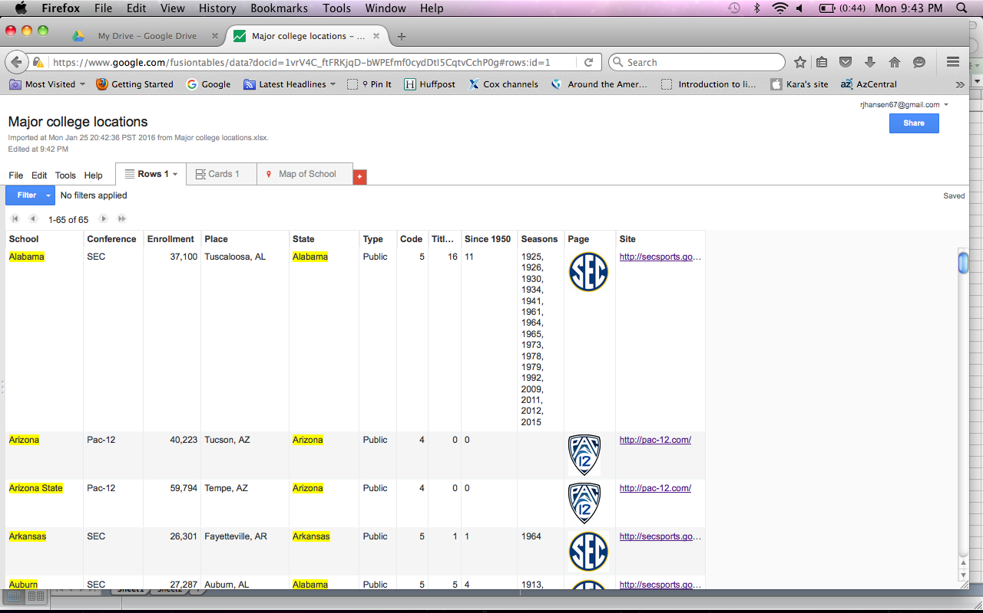

You’ll notice that the place column that we have (city and state) isn’t highlighted in yellow. This means FT doesn’t regard this as a geocode possibility. We could probably get some of our points without this, but let’s avoid problems and just tell FT to make the Place column a geocode item.

Click on the triangle in the Place column and select Change. Change Type to Location and click Save. You should now see that column in yellow.

Click over to the map tab and it probably makes a map based on the School column. Not surprisingly, it did a poor job. Notre Dame, for example, shows up in France, which makes sense on some level. Baylor shows up in Montana. Did you know there is a Baylor, Montana?

Change the feature style of the map to select Place as the basis of geocoding. It will take a minute to recalculate the locations, but should do it with no hitches.

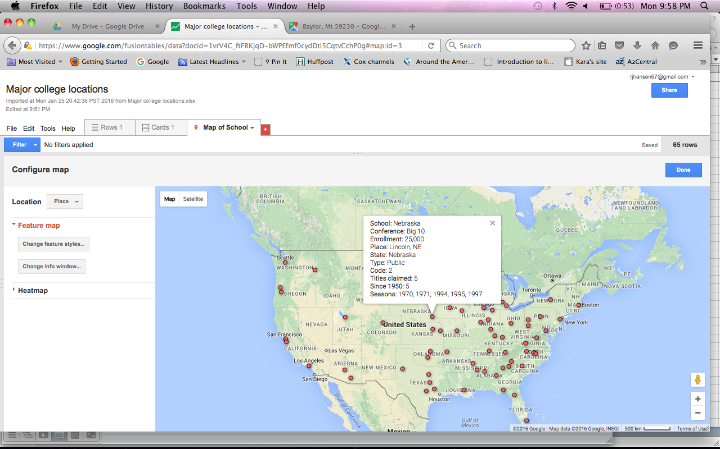Our map should come up looking like the one at left. Click on a point and you can see some, but not all of the information we’ve got for each school.

This is an OK map and not long ago you would probably say it’s fine for you.

Now we get to dress it up a bit.

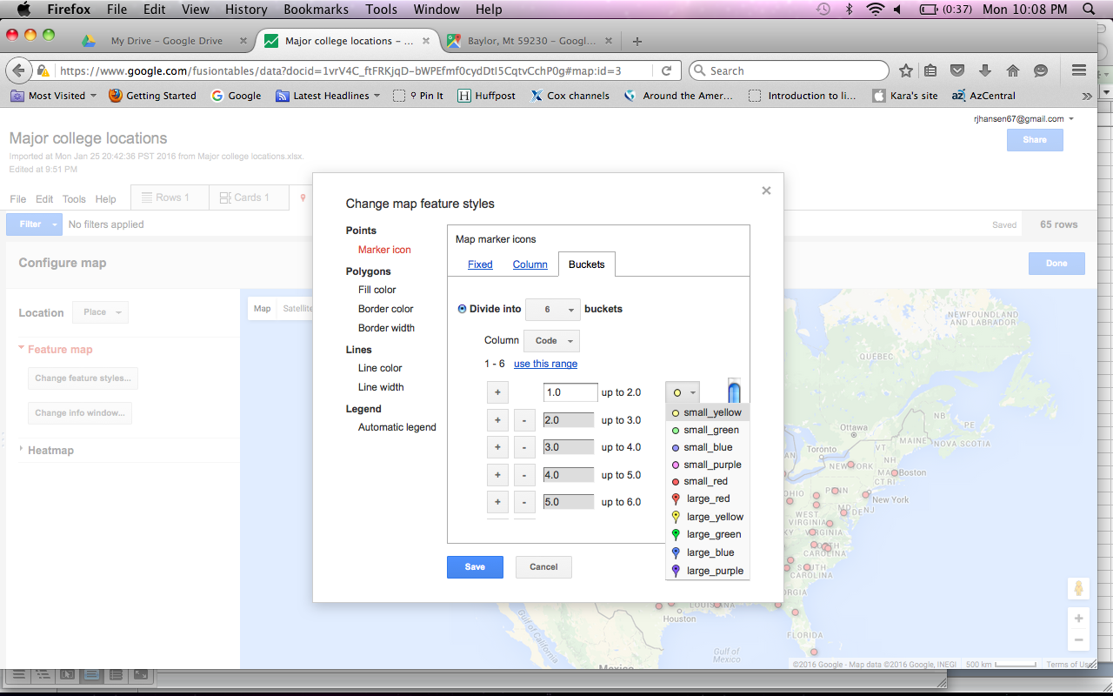First, let’s change the color of the points. Back to Change feature styles.

Make sure you’re on Marker icon in the Points section. Let’s choose Buckets. We have five conferences and one independent, so we need six buckets. Use the range that FT has identified for you.

The color options are also available to you to change as you like. I’m going to go with what popped up.

Click Save.

This is slightly more interesting because of the different colors. Let’s change the info box items, too.

Let’s uncheck the State and the Code columns and include the Page and Site columns.

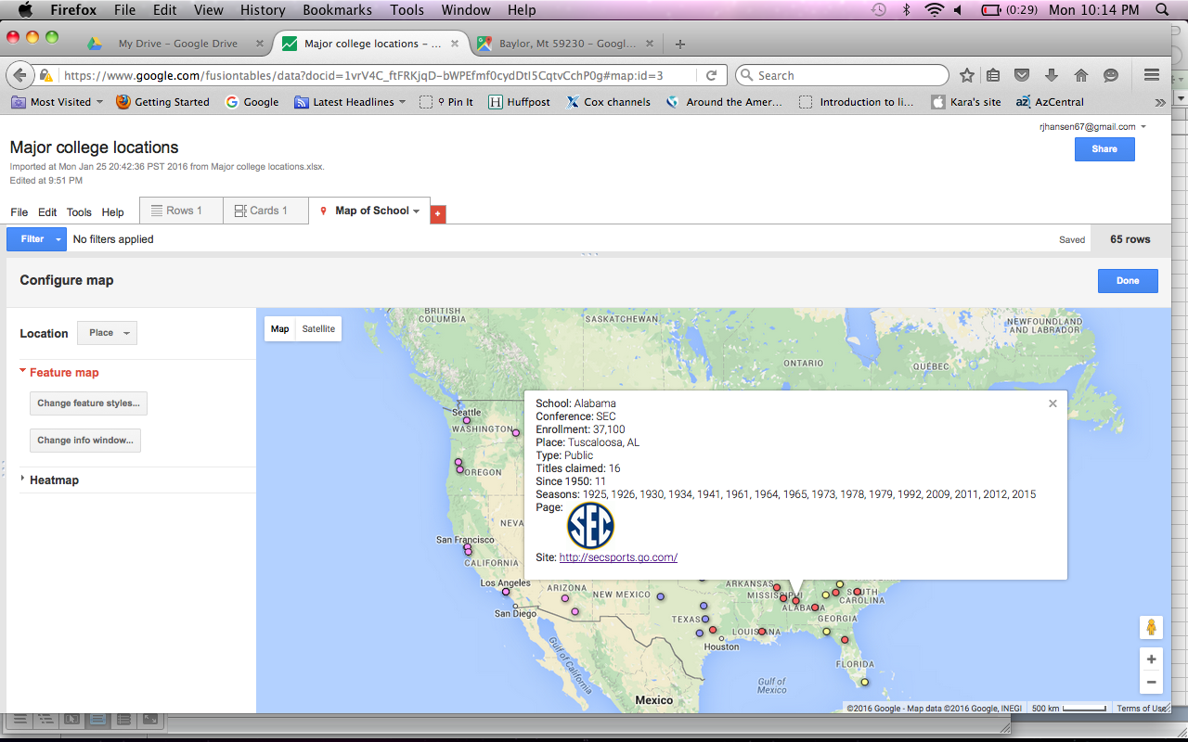

Now our information boxes include the logo for each conference and a link to the conference website.

The link is active and will open a new page if you click on it. This does not hurt your map.

Finally, let’s do something other than the basic map. Notice the button in the top left of the map window. It says Map and Satellite. Click Satellite and it should add an image-based map that gives us something a little more lively.

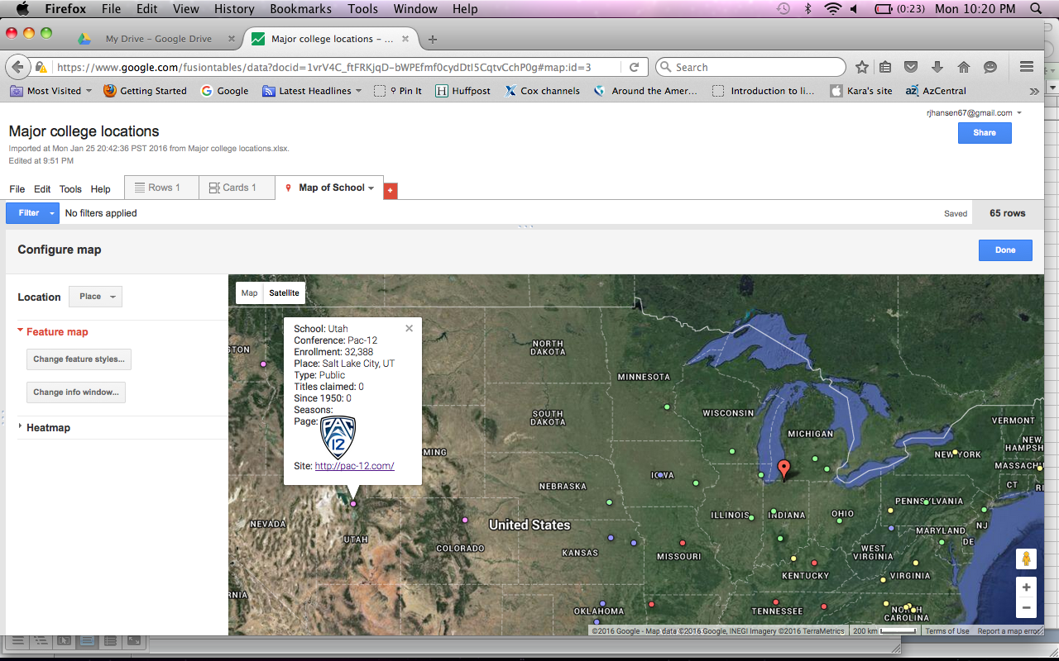

There’s one last thing to do with this map. If you look at these points closely, you’ll find that they aren’t really in the locations for the schools. We gave locations of city and state. For a crude map, this would work. For something more precise, we need better addresses.

There are two schools in Los Angeles, USC and UCLA. FT placed them both in the same spot, so no matter how closely you move in, only one dot ever appears. That’s not good enough even for a crude map. To change this, click on Rows 1 again.

Click on the row with USC and it should highlight the entire row. Notice the three icons in the middle of the screen? The first one, a pencil, allows you to edit the information for this row.

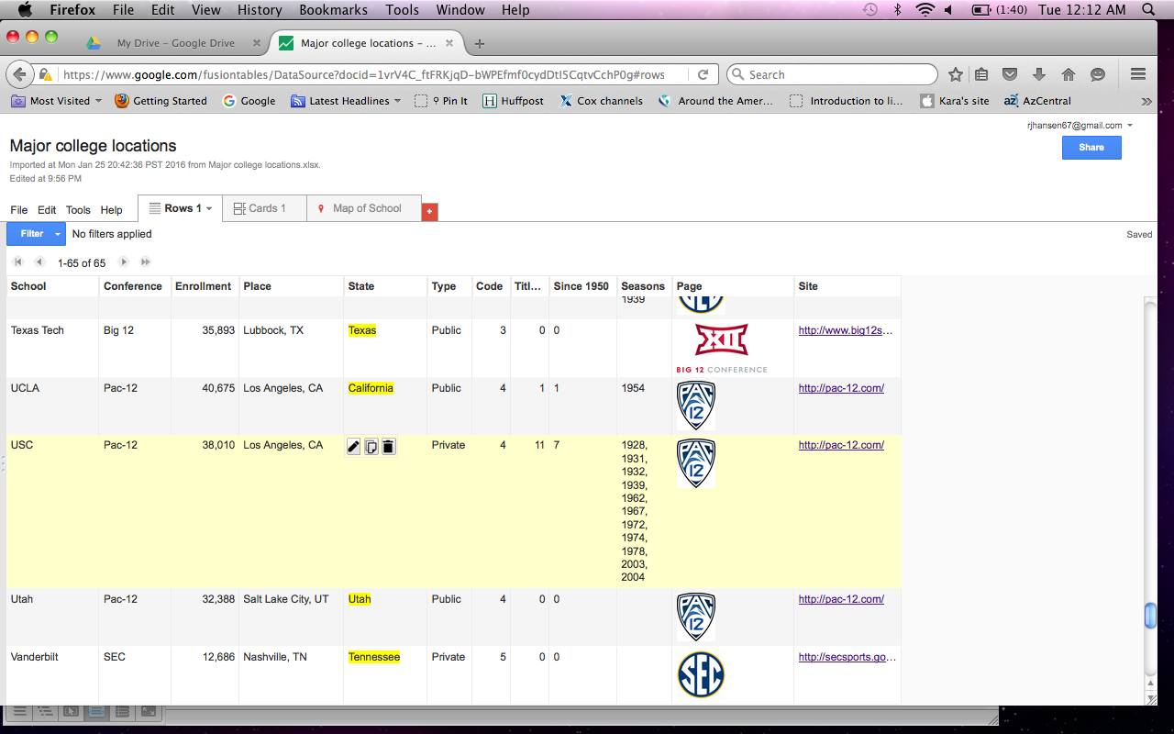

Click on the pencil and you get a window that allows you to change each item in the row. Under Place, you have an option to edit the geocode for Los Angeles, CA. Click on that option and it opens a map of Los Angeles with a marker for the current pin.

Type in more information in the text window, something like USC Los Angeles, and it should give you more options to locate the pin. Pick one that works for you and you’ve changed the location. If you needed the map to be precise, you may have to find exact school addresses or use some hints in geocoding for Google.

Now let’s add one more feature: video.

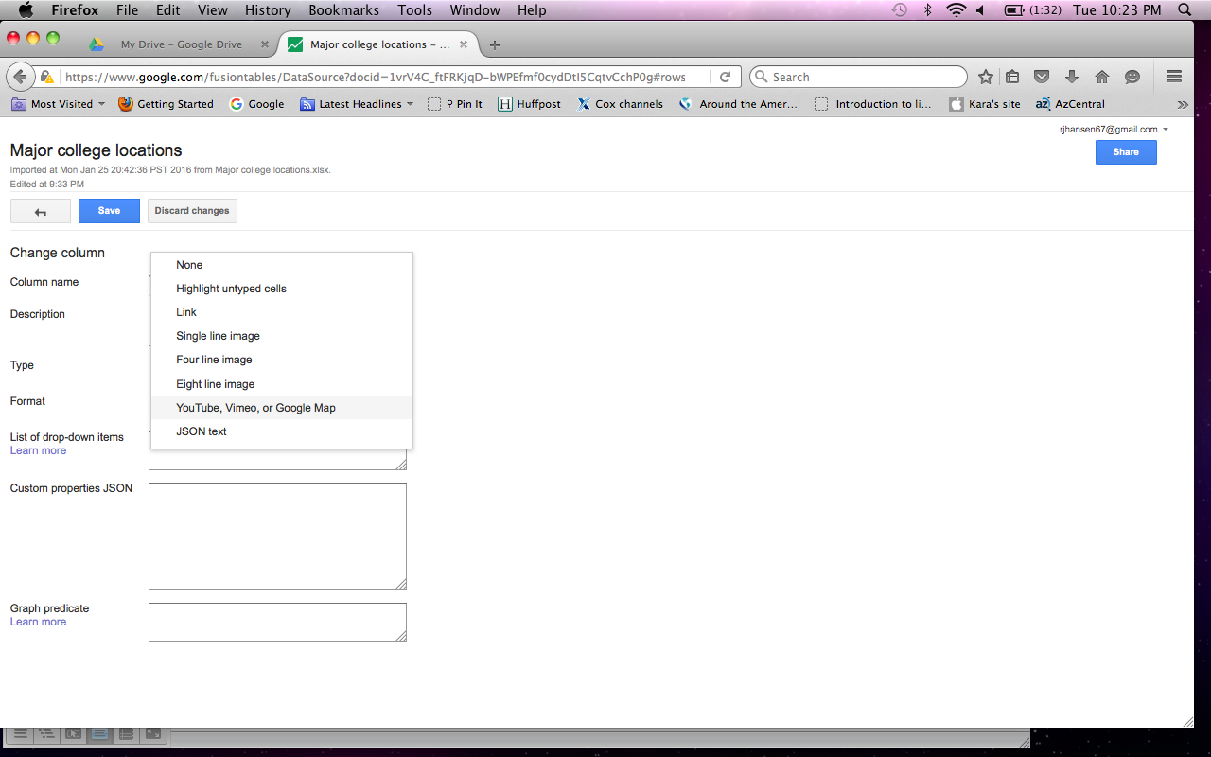

Back in Rows 1, the column editing feature allows us to make a change to accommodate video. Click on the triangle of the column you want to contain video information. I chose to replace the conference logo column, which is labeled Page.

A box should open that gives you the option to change Type. Click that and select YouTube, Vimeo or Google Map, then hit Save.

This tells Google that the information we will put in that column is a video file. (And the image files no longer work on the map page.) Now let’s get the video.

Open a new window and go to either Google or YouTube. Type in what you’re looking for. In this case, our first school alphabetically and in the polls is Alabama. I searched in Google for youtube Alabama beats Clemson.

A video that seems to have highlights of the national championship game pops up. Let’s use that. Click the Share button (with the arrow) below the video.

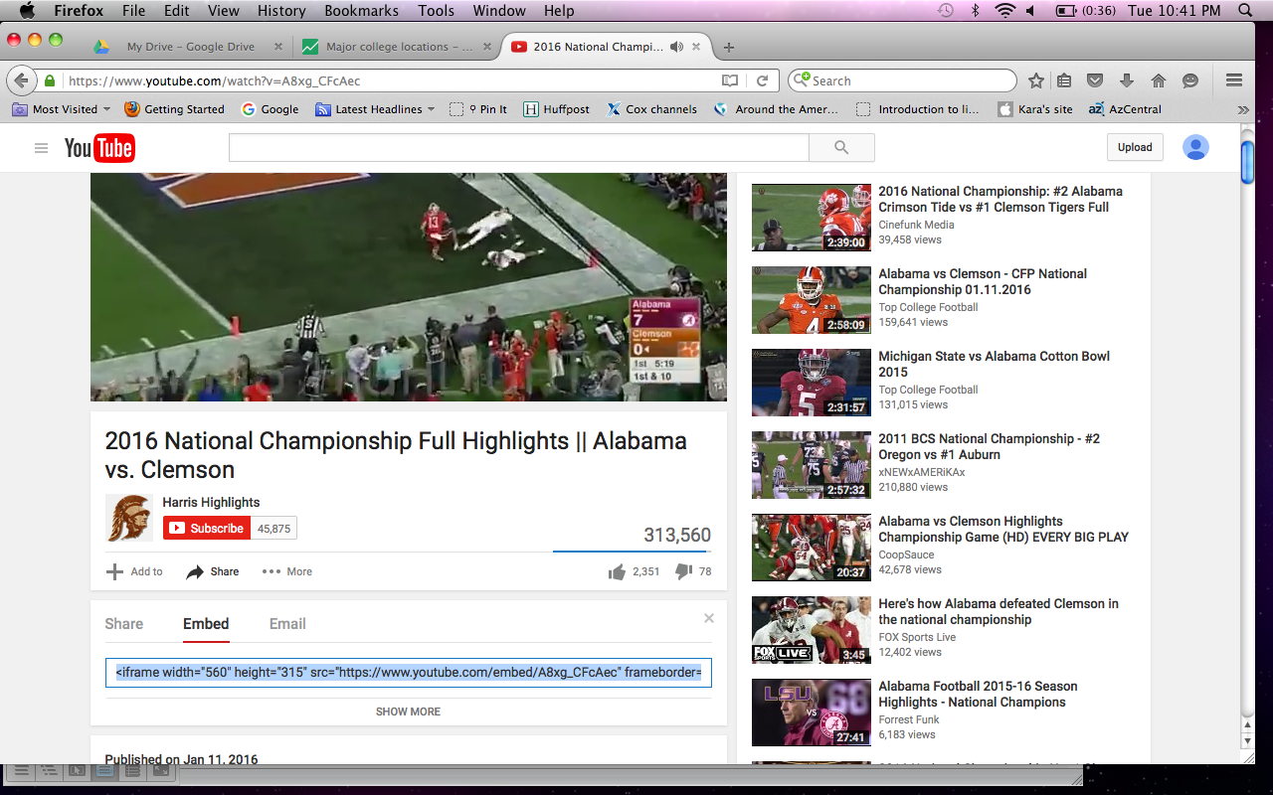

You have three options that appear: Share, embed and email. Click on Embed. A string of code known as the iframe tag for that video appears below. Copy that and paste it into the proper cell in Fusion Tables. Don’t forget to Save.

Now go back to the map view in Fusion Tables and click on Alabama’s location. What you should see is something like this:

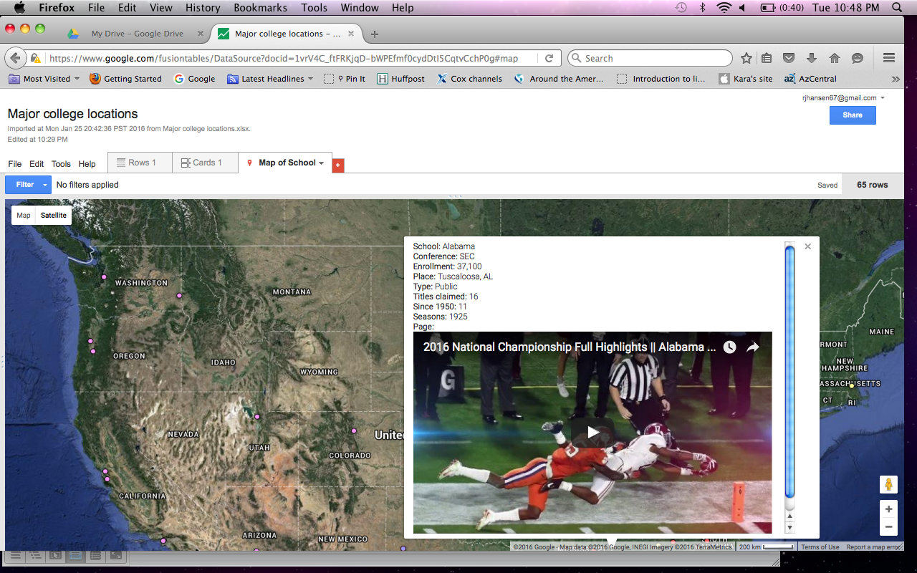

I think that’s a visually appealing map. We could find videos for every school on our list and give them the same deluxe treatment.

Now let’s do one more map today.

This time, we want to make a map, then layer it with one we’ve already done.

I grabbed the 2014 FBI crime data for the nation. In the interest of time, I’ve cleaned the data and trimmed it to include only cities with at least 200,000 residents.

I added two calculations and a description to this data as well. I calculated the violent crime rate per 100,000 residents and the same thing for the property crimes. I also added a column that combined the city and the state to make geocoding easier.

Now that we have our data ready to go, upload it to Google in the usual way.

Not surprisingly, the city and the state columns look like they can be geocoded. We will have to tell Fusion Tables to recognize the Place column as a location. From the Rows 1 tab, hover over the Place column and click the triangle. Choose Change and in the next screen change the Type category to Location. Save your change.

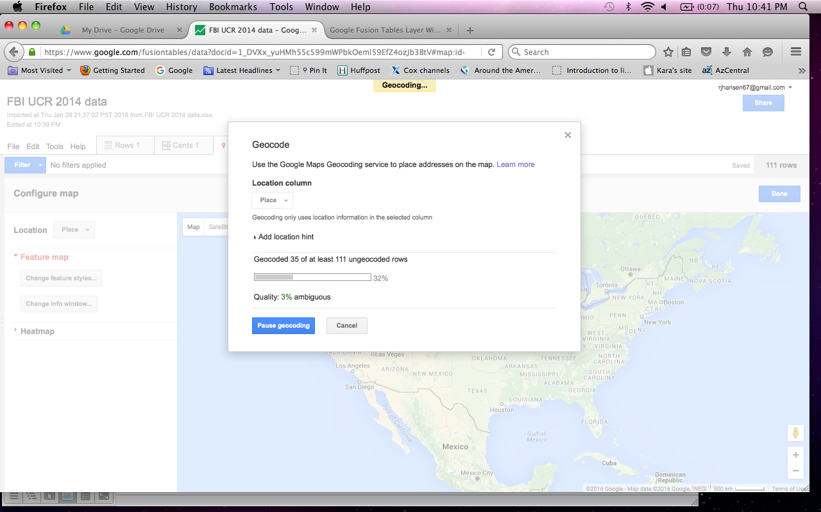Click over to the map tab. FT will probably begin geocoding, but not for the Place column. If you need to, pause the geocoding and change the data source to Place.

FT will begin geocoding the city-state data. This could take a minute.

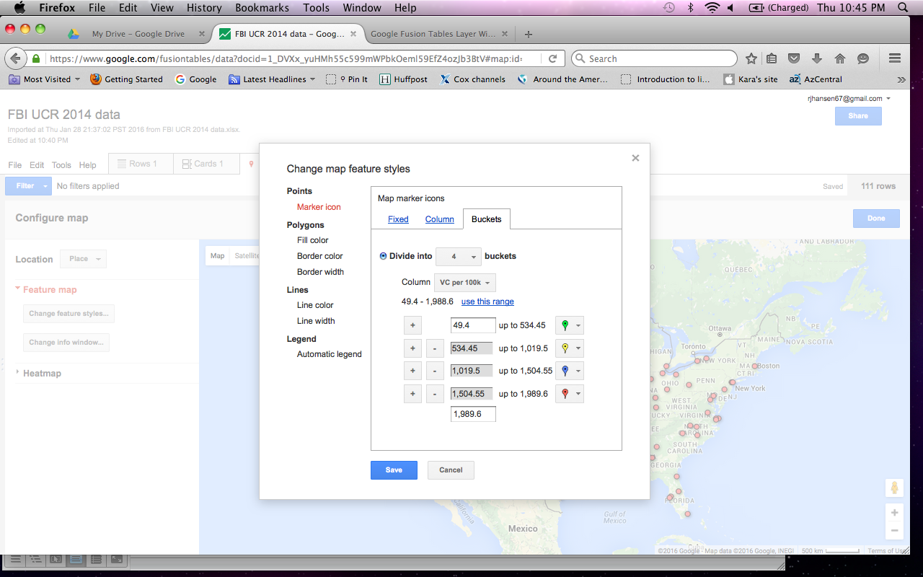Once that’s done, you should see red dots located across the map where you would expect to find them. Now let’s change those dots to something more helpful.

Click Change feature styles. Marker icon should already be highlighted in red. If not, make sure it is. Click the Buckets tab.

This will allow us to create color categories for our data. I chose four buckets and based them on the VC per 100k column. I clicked on the range hyperlink to use the spread based on the numbers found in the data. I also changed the dots to the bigger flags.

I used a color system that seems fairly intuitive, at least to me: green for the smallest numbers (or least violent locations); yellow for the second tier; blue for the third and red for the fourth bucket. That means red flags should be the cities with the highest rates of reported violent crimes.

Save your changes. The resulting map should be fairly easy to understand.

I modified the Share settings to make it publicly available on the Web.

Now let’s combine these city points with our county-based health data. Go back to that map in Google Drive.

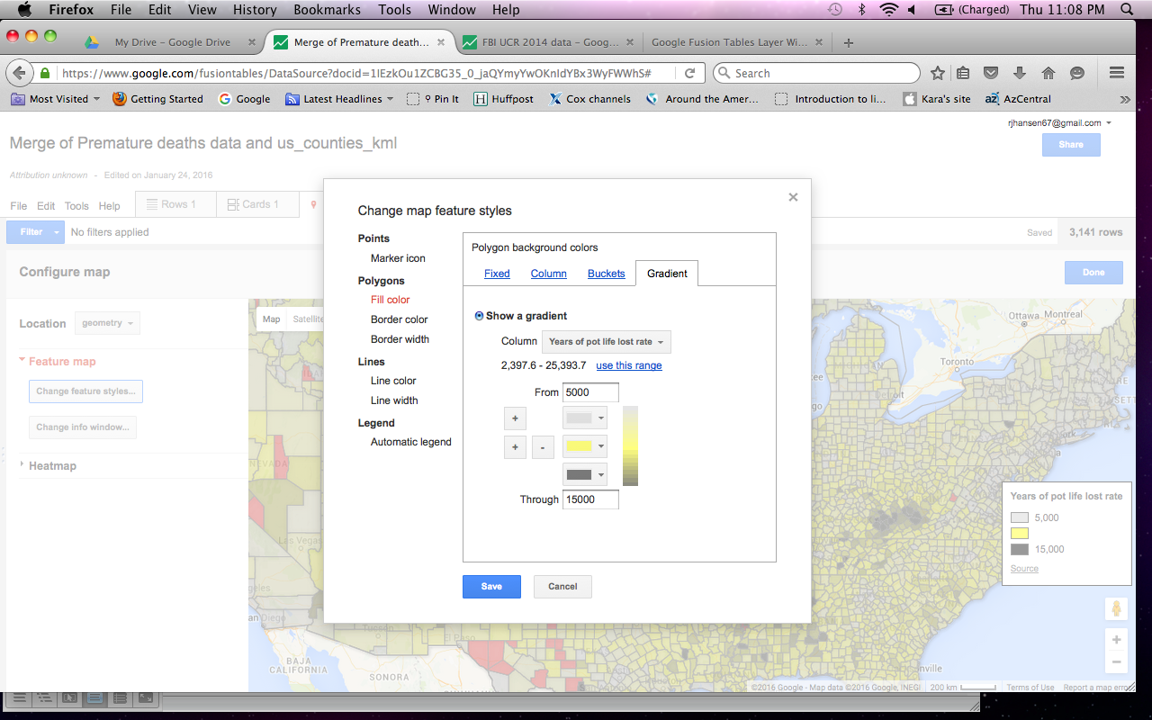

Let’s color that map using a gradient this time. Click on Change feature styles and make sure fill color is highlighted on the left rail under Polygons. Click on the Gradient tab.

Let’s use the potential life lost column and make three colors for that. Click the + sign or the – sign as needed to get to three color possibilities. I chose to make the colors gray, yellow and black for contrast.

I also adjusted the range to also highlight the contrast. I raised the bottom range to 5,000 and lowered the bottom range to 15,000. This has the effect of moving more locations into a category.

Click Save and your map should change to reflect the color scheme. Make sure your map is set to share publicly.

Now, let’s combine the violent crime map with the shortened lives map. To do this, we need the Fusion Tables Layer Wizard. This is not-so-helpfully found at the link below:

<http://fusion-tables-api-samples.googlecode.com/svn/trunk/FusionTablesLayerWizard/src/index.html>

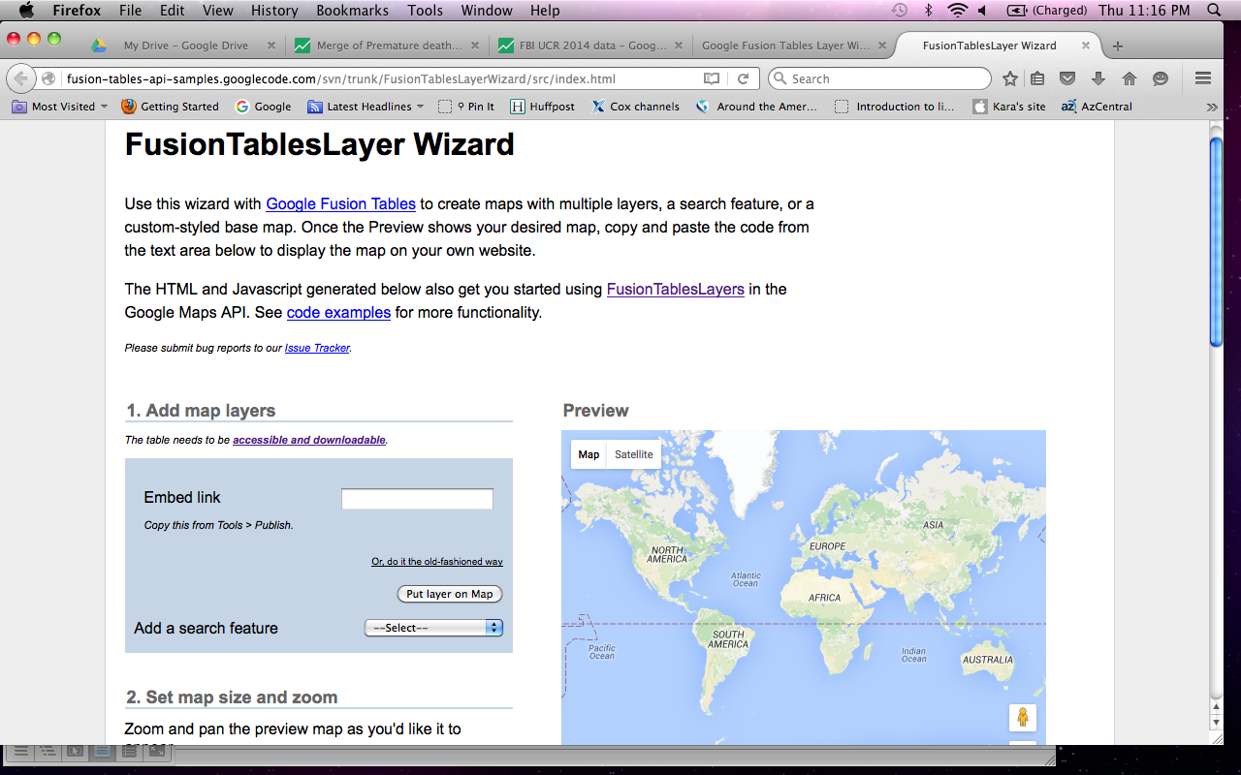

This is a tool that allows you to put the two maps over each other while keeping some of the distinct features of each one. While Fusion Tables can be a little tricky to work with, this wizard is pretty simple. You can probably do this following the on-screen instructions. Here’s a quick walkthrough anyway.



First, you need to put in an iframe link to one of the maps in the space next to Embed link. As it tells you, copy the link by clicking on Tools, then Publish in Fusion Tables.

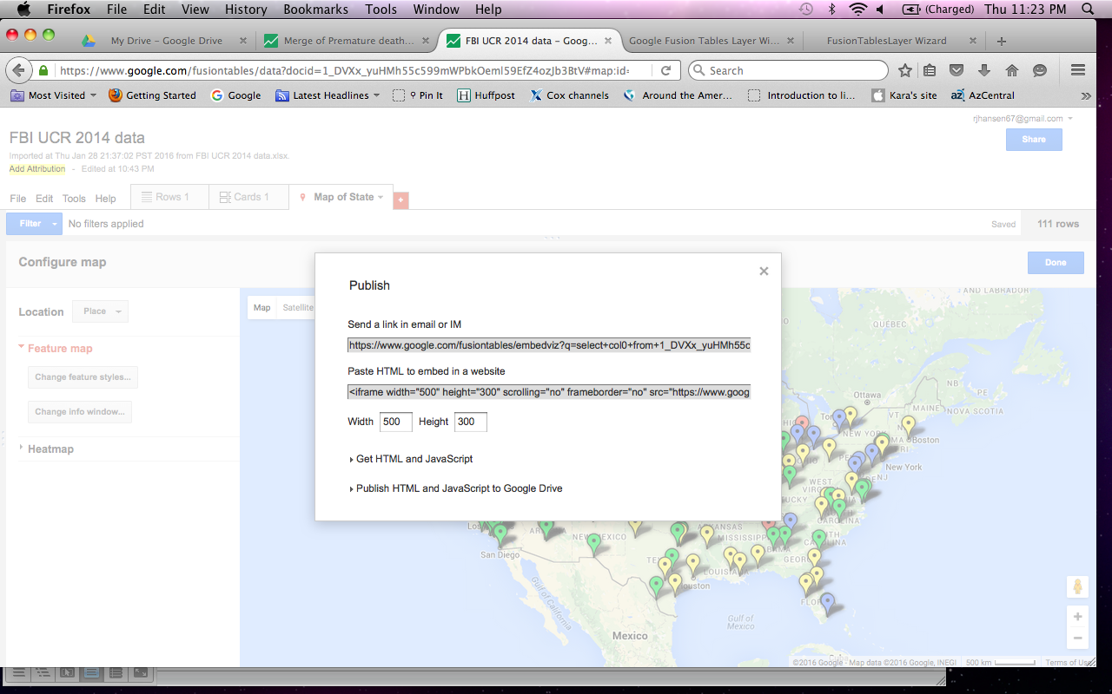I started with the FBI map. When you click on Tools and Publish, it opens a box that has two options: a link for email and a link for pasting HTML. Choose the HTML option (the bottom one).

Click in the box and it should highlight the whole string of code. Copy that and paste it in the Embed link box in the wizard.

Click Put layer on map. This should instantly put your crime data map in the box to the right.

Below that, is another button labeled Add Layer. Click that to add our second map.

Once again, we’ll need to copy the HTML code from the FT health data map and paste it into the wizard. Click Put layer on map. The second map should appear over the first one.

Next, you have the option to size the combined map. It defaults to 500x400. I want to change this to more of a widescreen graphic. I made it 800x400. Click Update map and scroll below. You should see your new map.

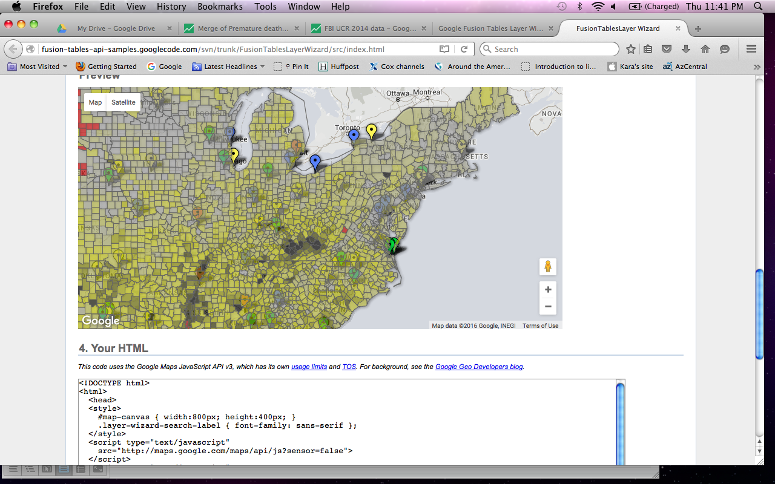

You may have to make adjustments to the colors to make sure they interact the way you like best.

You’ll notice that each of the boxes where you pasted the HTML code also have options to include a search tool. This gives you the option of filtering the data by some criteria you pick.

Below your finished map is the resulting HTML code to copy and paste into a website if you want to publish it. Even if you don’t, this is a place to play with a combined map.

**Here are a few resources and tips from others for working with Fusion Tables.**

Here’s a great resource for getting going with Fusion Tables:

<https://datasense.withgoogle.com/ftbasics>

And here’s some basic support from Google:

<https://support.google.com/fusiontables/answer/184641?hl=en>

Here’s where to search for boundary maps in Google:

<https://research.google.com/tables?corpus=fusion&hl=en&q=boundaries>

Ken Blake’s website:

<http://mtweb.mtsu.edu/kblake/datajournalism.html>

Mu Lin’s blog:

<http://www.mulinblog.com/google-maps-tutorial-part-1-what-fusion-tables-is-and-does/>

Here’s a very quick rundown on making graphics using Fusion Tables:

<https://www.youtube.com/watch?v=pRqAJwL6_3s>

Here’s a page for commonly requested KML files:

<https://support.google.com/fusiontables/answer/1182141?hl=en>

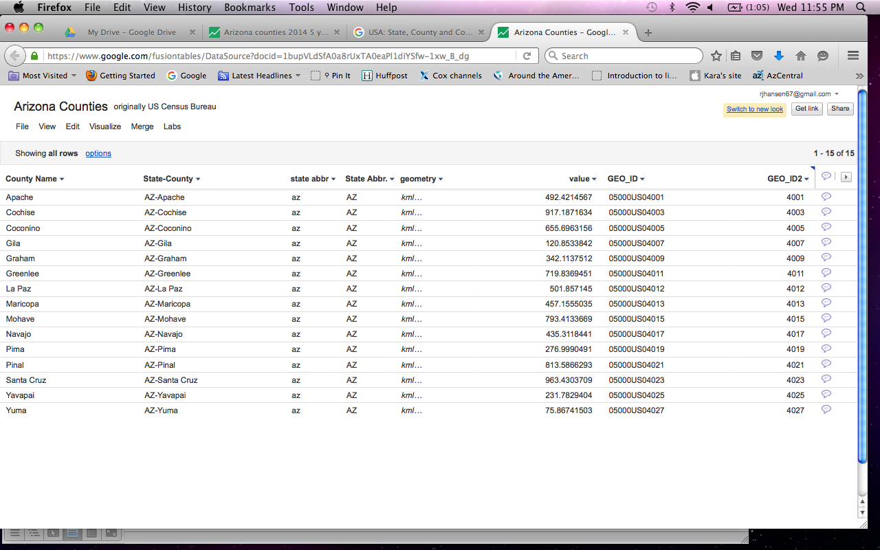If a file opens and looks strange to you, it might be displayed in an earlier version of Fusion Tables. There should be a link to click in the right corner to Switch to new look. Click that and you should see something that familiar and like what we need.

To add a column, go to Edit and Change Columns.

To geocode a column that isn’t already recognized, click on the column pulldown menu and select Change. From there, change the section labeled Type. Select the option for location. Save your changes.

**Move a pin**

You can also correct the location of a specific point yourself:

1. In your table, find the row with the wrong location. The address field is likely to be in yellow.
2. Double-click the row to bring up the editor dialog.
3. Click the “**edit geocode...**” link below the address field.
4. The current location is shown with a green arrow.
5. To change the geocode:
   1. Search with any text until you see a red map pin located in the correct place.
   2. Click the red pin, and then click “**Use this location**.”
   3. Click “**Save**” in the editor dialog.

## Add new rows to a table

It's easy to bring [additional rows into an existing Fusion Table](http://support.google.com/fusiontables/bin/answer.py?hl=en&answer=180803) using **File** > **Import more rows**.

#### Try it yourself!

Imagine you are tracking all vacant or abandoned buildings in Chicago, each of which was identified by a service request on a specific date. The table has data through March of 2011 and now you want to add in April's data.

We've created some sample data for you and put April's new rows in a Google Spreadsheet.

1. Download the sample file to your computer: [Chicago's vacant buildings](https://www.google.com/fusiontables/exporttable?query=select+*+from+1c5idWJKxg4dLtUWCauIhEllMqCaRLrXgc_hMaCk)
2. Create a new table with the example dataset:
   1. Go to [Google Drive](https://support.google.com/fusiontables/answer/docs.google.com" \t "_blank) and click **Create** > **More** > **Table**.
   2. Click **Browse** to find the file on your computer.
   3. 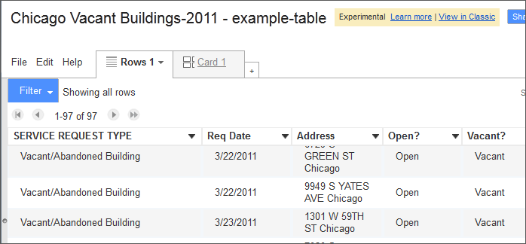Click **Next**, **Next**, and **Finish** to create your table. It should look [like this](https://www.google.com/fusiontables/data?docid=1c5idWJKxg4dLtUWCauIhEllMqCaRLrXgc_hMaCk):
3. Now bring in April's rows:
   1. Choose **File** > **Import more rows**
   2. Select the file with the new rows.
      * Choose **Google Spreadsheet** from the left bar, and paste the URL to [this spreadsheet with April's rows](https://docs.google.com/spreadsheet/ccc?key=0AthtKoV1ZaKUdFQ5MUpSa0lNWXZSNU80a0dpTkEyZkE).
      * Or, download [this CSV](https://www.google.com/fusiontables/exporttable?query=select+*+from+19kgWirlPhztQexJYHmTn6eFe7eEFO3ZBhfDzy34) and click **Browse** to find the file on your computer.
   3. Click **Select** and **Finish** to bring the rows into your table.
4. Confirm the new rows are in your table.
   1. Click **Req Date**
   2. Select "**Sort Dec 31, 2012 to Jan 1 2012**" to sort the recent dates to the top.

## Bulk replace all rows in a table

What if any row might have updates, or even some rows have been deleted? You have a file with the latest version, and now you want to update the Fusion Table too.

The best way to do this is a quick 2-step: delete all rows, then import the new file with all the changes back into the table. This way, you aren't creating a new table, just updating an existing one.

1. Since deleting all rows can't be undone, you may wish to **File** > **Download** a copy of your current table as a precaution.
2. Delete all the rows:
   * In the new look, use **Edit** > **Delete all rows**.
   * In **classic**, use **File** > **Delete** **all rows**.
3. 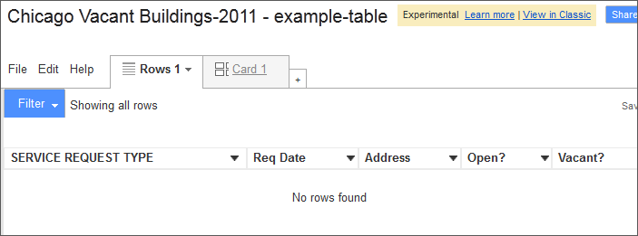Click **OK** when prompted.  
     
   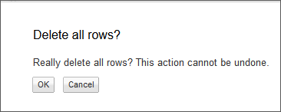

Here's your empty table once you've deleted the rows:

1. Now use **File** > **Import more rows** to bring the new version of the data into your table.

Your original table is updated with the latest information.

To manually see thumbnails in your table:

1. Click the column name containing the URLs and choose **Change**. Or, Click **Edit** > **Change columns**.
2. Select an image format from the **Format** dropdown menu. For example, "Four line image" format displays thumbnail images as tall as four lines of text.
3. Click **Save**.

# Is Fusion Tables still being actively developed?

### by Michael Matis

Jan 22

Just wanted to say I LOVE this app. We're using it to store, visualize, and present inventory and assessment data of classrooms at my organization. The card templates in particular make it so easy to build what amounts to a custom report or UI, essentially making Fusion Tables a "meta-app." My only question is if FT is still being actively developed? Is there a place to go for news on its progress? I know it's "experimental"... does that mean it could be removed from Google's offerings at some point?

### Rod McChesney said:

Good to hear it's working well for you! We do have a team working on it, though mainly on back-end code nowadays. There are no current plans to turn the service down, but as its experimental status indicates, that's no guarantee for the future. There will be sufficient warning if that happens, however.

That said, I would recommend regularly backing up your FT data to CSV files -- a good practice regardless!